Alfred Wegener and the theory of Continental Drift -
Writing Assignment
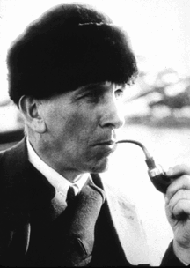

Role: A current-day earth scientist
Audience: The National Philosophical Society members (1924)
Format: Speech
Topic: Current Evidence to help support/prove Wegener’s theory of Continental Drift

Write a speech that you will give to the National Philosophical Society members in the year 1924. In your speech, you will need to do the following:

- Introduce yourself as a scientist/time traveler who has come to update them on Wegener’s research.
- Give a brief summary of Alfred Wegener’s original theory of Continental Drift.
- Update them on 2 or more discoveries that have been made since 1924, that support/prove Wegener’s original theory.
- Conclude your speech with a one-two sentence summary of the current theory of plate tectonics.

You will need to write a draft of this speech, then edit and revise it before typing a final copy.

